**Bouw van een plant**

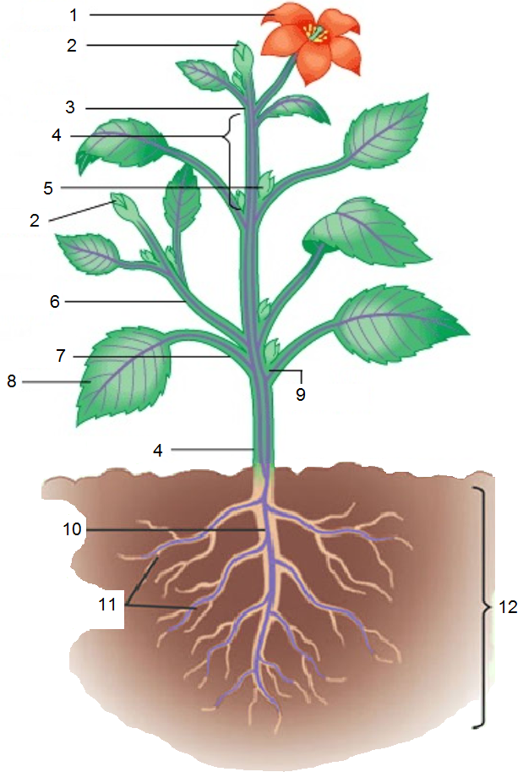

|  |  |
| --- | --- |
| Naam leerling: |  |
| Klas: |  |
| Datum: |  |

|  |  |  |  |
| --- | --- | --- | --- |
| **1** |  | **7** |  |
| **2** |  | **8** |  |
| **3** |  | **9** |  |
| **4** |  | **10** |  |
| **5** |  | **11** |  |
| **6** |  | **12** |  |